The making of medieval shoes according to methods from the turn of the 14th century
with modifications for shoes from the 10th to the 15th century

by

Lord Maximilian von Brandenberg

A class taught at Kingdom Arts and Sciences AS XXXVII

I have attempted to create a fairly complete pamphlet about the construction of shoes. It is intended to give you a step by step instruction of making shoes even without a book at hand. In the end you will find that making a shoe is easy. Explaining it is not ☺

You can wear a medieval shoe too! 2
Dispelling myths: 2
Let’s be real: 2
Needed materials and tools: 2
Leather 2
Scissors/Knife 3
Needles 3
Thread 3
Awl 3
Overstitch wheel 4
Making the shoe 4
Type of shoe 4
Measuring the feet 4
Method 4
Tracing the foot 4
Completing the tip 4
Measuring across the foot. 5
Circumference 5
Last measurements 6
Drawing the pattern 6
Creating a cutting pattern on paper 6
Cut out the pattern. 6
Transferring the pattern to leather 6
Making the rand 7
Making the heel stiffener (optional) 7
Cutting the leather 7
Other piece of leather to cut out 7
Sewing the shoe 7
Stitches 7
Setting up the two needle harness 7
Attachment of the upper to the sole 8
Closing the side seam 9
Turning the shoe 9
Adding the clump sole 9
Literary sources to look up: 10
Glossary: 10
Figures: 11

You can wear a medieval shoe too!
Finding the right shoe to fit in with your persona or your idea “medievalism” is often very difficult or expensive. As a result many people who make an honest attempt at being their most medieval, end up wearing the closest thing to a medieval shoe they can find. In the worst case this may even be the dreaded sneaker.
Yet, making shoes is fairly simple. Done right, a medieval shoe is extremely comfortable and, with some adjustments I will outline below, can be made to fit even the most sensitive, modern foot.

Dispelling myths:
Medieval shoes do not have to have long points (which are called “poulaines”).
The points do not curl up, except for extreme cases at the very end of this fashion.
Medieval shoes do not have a seam down the center of the arch of your foot.

Let’s be real:
There are some things which we either cannot easily recreate or shouldn’t recreate. I will list those points here briefly, so you can think of that as you read through the notes.

- Soles
Shoes in the middle ages basically always used a single, thin piece of leather as a sole, until the beginning of the 15th century when secondary, so called clump soles, were put on the shoes. I will be talking about putting rubber soles on your shoes, which of course is a pure modern adaptation with a nod towards the robustness of medieval feet which we don’t possess.
- Thread
The thread that was used most of the time was waxed flax, but also silk was used. I mostly use a thin strong linen thread. Waxed thread, sinew or fake sinew, as used for leather work tends to be much to thick. For making waxed thread, simply draw the thread over a chunk of beeswax.
- Leather
The leather you will most likely use is cow hide. Close, but not quite. What was used for a long time (up to early 14th century) was goat or sheepskin, also called cordwain, but later calf was used most of the time. Other leathers were probably used too, like deer for example, but most surviving examples are goat/sheep and calf.
- Needles
The tools the shoemaker used most are a knife, an awl and a boar bristle. Holes were pre-punched with the awl. The thread was then pulled through the hole with the boar bristle. Needles were used too, but only later. I usually use tapestry needles or regular needles with blunted points. A blunt needle will not try to punch its own hole.
- Lasts
Lasts are basically wooden feet. They used to be carved to the right size. Then the leather was formed around these lasts and sewn. I don’t have lasts and you probably don’t either, so we’ll do without.

Needed materials and tools:

Leather
Type
You are free to use whatever leather you like, as long as it is calf (just kidding). Cowhide is the most likely material you will be using. As mentioned before, cordwain was used up until the mid 13th century. After that, probably due to a better supply of cattle, calf was used more and more. This tells us a very important aspect of the leather used. It should be supple. A shoe can certainly be made from stiffer leather, but it is not as easy to turn. Other leather, such as deer, works just fine.

Grain
One thing is very important though. Do not use suede. The leather you use, must have a grain side for strength. As a matter of fact, the thicker this layer the stronger the leather and the easier it is to sew.

Thickness
The leather should about be about 1/16 to 3/32 thick. Thinner leather is harder to sew, but not impossible, thicker leather make a shoe harder to turn.

Tanning
The leather should be vegetable tanned leather. Historically the leather used was oak tanned. This type of leather is easy to dye and to engrave. Vegetable tanned leather usually is skin colored and the cross-section is colored the same.

Scissors/Knife
Leather is an incredibly tough material. Its tensile strength is enormous, even when wet. Yet, with the right tool it is very easy to work. Scissors or a knife are the best tools for the job of cutting. Historically the knife of the shoemaker was a half-moon shaped knife with the handle attached in the middle. It is a very good knife, but usually very expensive. Modern roller knives work as well. I personally prefer leather scissors because I can cut much more precisely with them.

Needles
Do not use lacing needles. These mostly black anodized, flat needles which snap open at the end where the lace goes, are used in combination with a chisel. A chisel cuts holes about 1/8 inch long and is the wrong tool!
Use regular sewing needles or embroidery needles, depending on the job at hand. If you pre-punch holes with an awl, then use embroidery needles. The blunt tipped needles tend not to get stuck in the leather and follow the hole you’ve already punched. If you have a part of the leather that is not pre-punched, then use regular sewing needles. Be prepared to work with a thimble if you have sensitive fingers.

Thread
The thread which was mostly used in the middle ages was waxed flax. I usually use linen thread or similar material. The thread is about as thick as regular sewing thread. Of course strength is an issue, but linen or silk are definitely period materials and at least the latter was in fact used in shoes as well. The artificial sinew sold in the leather stores tends to be too thick, although it can be split down to the right thickness.

Awl
The awl is something like a needle with a diamond shaped cross section and a wooden handle. It too is a historical tool used to pre-punch holes in the leather. Not all holes have to be pre-punched. This depends to the amount of leather which needs to be pierced. A leather needle, which has a cross-sectional shape like an awl, or even a strong sewing needle can do the job as well.

Overstitch wheel
This handy device helps you make your stitches evenly spaced. Obviously it is not really needed, but it makes for nice work and is invaluable in matching up awl holes.

Making the shoe
Now lets start making a shoe.
Making shoes is fun. Similar to making chain mail, sewing a shoe involves a lot of manual labor which however can be done in front of the TV and is a calming activity. Be prepared to take much longer than you think, but the result will be worth it. A handmade shoe was meant to last no longer than a few months, in the middle ages. Today such a shoe will last for years. In fact my lady is still wearing shoes I made for her about 5 years ago. This is of course due to the decreased amount of usage, but considering that I made every mistake in the book it is not too bad. These shoes where made from suede leather (a no-no), with a one layer sole about 1/16 inch thick (much thinner than one would expect, but correct)

Type of shoe
Let’s talk about the type of shoe we will be making. It is a turn-welt shoe. This shoe has the following parts:
- The upper leather, made from a single piece of leather (up into the 15th century this was often pieced together a bit)
- The heel stiffener, helpful for maintaining stiffness and shape (optional)
- The sole, a thin piece of leather directly in contact with bottom of the foot
- The rand, a strip of leather surrounding the shoe, between the upper and sole.
- The clump, a thick piece of leather sewn to the rand underneath the sole.

The shoe looks in essence like a modern shoe, an ankle-shoe. There is a good reason to start with such a shape. First of all it is easy to make. Second it is the basic shape used to make a boot as well.

Measuring the feet

Method
The method used for making a pattern is the tree method used for hosen and other garments often found in garb books.
To do so you will first trace your foot, then measure across the arch and around the ankle. This will then be transferred to another piece of paper, turned into a tree pattern and cut out.

Tracing the foot
To measure the feet (measure both, since feet are never symmetrical) have somebody trace your feet on a piece of paper you stand on. This allows your feet to widen appropriately as you put weight on them. Place the pen vertically on the paper and trace. Just for the instep, angle the pen such that the tip goes under you foot a bit.

Completing the tip
When you have finished tracing the foot, you need to draw something close to a middle line through the outline of your foot.
Important: This should *not* be done just through the middle.
Take center of the curve of the heel at the very end of the outline and draw from there to a point between your big toe and the second toe. It’s even better if you draw slightly onto the second toe, on the side facing the big toe. Extend the line beyond the toes as long as you want the tip to be.
This line will not bisect your outline. This is correct. If you were to bisect the outline of your foot exactly, the points of your feet would look like they are pointing outward when you wear your shoes.
Now complete the drawing of your foot by drawing a tip onto your foot. To do so trace lines from your pinky toe and your big toe to a point of your choosing on the central line. The most popular tip length was roughly 10-20% of the foot length. Very long tips as in Poulaines require special stitching and turning.
However, do draw a tip. Shoes in the middle ages never followed the outline of your foot. If you’d rather make a rounded tip, center it on the central line you drew.
When you have completed both feet, superimpose the two outline by flipping one over and hold the pieces up to a light. If your feet are similar I would recommend “averaging” the two outlines. In general, deviations of ¼ inch could be due to mistakes during drawing or actual differences in the feet, but that is no problem. By averaging you only have to make one full pattern and not two. If you have averaged your patterns to one pattern take it and continue. Otherwise repeat with the second one.

Measuring across the foot.
To get an accurate measurement of your foot you also need to have measurements across the arch of your foot. Since your foot is a somewhat irregular shaped body part you’ll have to measure several times.
Start from the tip you have just drawn and make a mark on the central line every inch. You will not use all of the marks, but don’t worry about that. Draw lines perpendicular to the central line through the marks you made. Make sure to extend the lines beyond the edges of your outline for at least one inch. You will later have to use the points where the horizontal lines cross the line of your outline.
Now start on the first set of marks that has some toes in between. This might be the second or third mark from the tip, depending on the length of your tip. Use a tape measurer or even better, a string. Place on end on the line of the outline of your foot, where it is crossed by the horizontal line, pull it across your foot and pull it down to the corresponding point where the horizontal line crosses the line of the outline of your foot on the other side. For the first or second mark, that basically make up the tip of your shoe where your toes don’t reach, estimate the measurement. If you are not sure about your measurement, repeat it. I usually measure each measurement three times and average the values. Write down the measurements near the central line by the appropriate mark.
Work your way back on your foot, always using the marks, until you come to the end of the arch of your foot where it turns into the ankle.

Circumference
Pick a spot roughly below your anklebone by your instep and make a mark on the outline of your foot. This will be the location of the seam closing the upper leather. These seams were always on the inside of the foot, especially in later periods (13th century and further). Now, using a tape measurer, measure from the tip of the shoe once along the outside, around the heel (note measurement of center of heel position) and up to your mark at the instep. Then measure from the tip along the inside to your mark. Note the measurements on your piece of paper. Together these measurements will be the total circumference of your foot.

Last measurements
With the foot still on the pattern measure from the point of the tip to the end of your arch where it turns into the ankle.
Also, measure the height that your shoe should have. The explanations given here work for a ankle shoe, so the height should be no more than 3 or 4 inches.
Measure the circumference of your ankle, right where the top edge of your shoe will be.

Drawing the pattern

Creating a cutting pattern on paper
Take a piece of paper the length of the circumference of your foot and at least as wide as the largest measurement across the arch of your foot.
Draw a central line along the middle of this paper. Mark a spot on the line for the tip of the shoe. Now mark off every inch along the line and then again perpendicular lines. Use your measurements you made across the arch of your foot and transfer those measurements to the pattern at the appropriate inch mark. Center each measurement on the central line. When you have transferred the last measurement, the one which is right where your ankle starts, connect the endpoints of each measurement to form a large, irregular U. Do not make the tip too sharp. A good deal of rounding makes manufacture much easier and still results in a nice sharp tip. When you round the tip, just follow your feeling and don’t make a point. The pattern will shown what is “right”.
Take the last and largest measurement you have transferred onto your pattern and draw a line from this mark parallel to the center line of the pattern. This marks the part of the shoe that wraps around your heel and meets the edge of the upper leather at the seam on your instep. Now take your circumference measurement, which goes from the tip of the shoe around the heel and up to the mark on have made on your inside of your foot pattern. Take this measurement and transfer it from the tip, along the outside of the pattern and then along the parallel line you have made. Mark the end of the measurement and mark the position of the center of the heel. Finish the pattern by drawing a line from the end of the measurement perpendicular down to the center line of the pattern. The pattern now looks like a huge P where the top part is the upper leather that covers the arch of your foot, the “vamp”, and the leg of the P is the long box that goes around your heel, the “quarters”.
If you were to cut this pattern out now you could take the end of the long rectangular box and connect it to the other side of the open end of the U. The shape of the shoe is becoming apparent.

Cut out the pattern.
Important: I highly recommend to trace the pattern onto a piece of non-stretchy material and making a cloth shoe first! This way you can adjust where you need.

Transferring the pattern to leather
Now take your finished pattern and lay it onto the leather, on the “flesh” side. Trace it with a pen.
Important: Now take the patter and flip it over before you trace it again for the other foot. Having drawn the pattern on the flesh side of the leather, the piece that looks like a regular P is the right foot. Label the leather with left and right.
Cut out the pattern. You will notice that there is no seam allowance. This is on purpose.
Don’t forget to do the same for soles. Don’t forget flipping the pattern.
Cut out the patterns.

Making the rand
The rand is a strip of leather that is sewn between the vamp and the sole. It was used to fill the seam that is pulled open by turning the shoe. Later, in the 15th century, this strip was made much wider, called a welt now, and used to attach a secondary sole, the clump sole.
The rand was wedge shaped in cross section, but that requires a skiver, a tool that most people won’t have. But, it works just as well if you don’t skive it.
Important: If you want to make an earlier shoe, from roughly the 10th century up until the 12th and 13th century, just leave off the rand.
To make the rand, just cut of a strip of leather, about ½ inch, a bit longer than the circumference of your shoe. If you can’t, several piece will do as well. It’s period and just requires a bit more careful sewing.

Making the heel stiffener (optional)
Cut two pieces of leather, roughly two inches wide on the bottom and roughly 2/3 of the height of your shoe. Keep the bottom edge straight and round of the other edge, making a type of dome.

Cutting the leather
Cut out the leather without seam allowance. What works really well are leather scissors or, for a period touch, use a shoemakers knife which is shaped like a half moon with a handle.

Other piece of leather to cut out
Depending on how fancy you want to get you can also make heel stiffeners and a tongue.

Sewing the shoe
Before you can sew the shoe together you need to pre punch the holes. The easiest and best way is to use a spacer wheel and an awl. The spacer wheel looks a little bit like a gear on bicycle, attached to a handle. This can be rolled across the leather and makes little, evenly spaced indentations. The awl is a basically a big needle on a stick ☺ Awls tend to be diamond shaped in cross section. When you use this, make sure to rotate the awl about 45 degrees. This way the thread will not pull into the corners of the hole and tear through.
Stitching the shoe is not complicated. It takes a bit of time and patience. It’s a great thing to do in front of the TV.
Usually you will be working with a two needle harness. This means you use one thread and a needle attached to each end of the thread. I usually use carpet or tapestry needles because they don’t have a sharp point.

Stitches
There are just a few basic stitches used for most shoes. They are called the edge/flesh stitch (Figure 3) and the grain/flesh stitch (Figure 2). In normal English this is a stitch that goes from the in through the edge and out the flesh side of the leather. The other goes all the way through the leather, from the side where the hair was, the grain side, to the flesh side.
Figure 6 shows how the upper, via the rand, is attached to the sole. The following modifications are to be considered for different time periods. For shoes prior to the 12th century, ignore the rand and use only the grain/flesh stitch. For shoes between the 12th and the 14th century, use a rand. For shoes in the 15th century, use the clump sole.

Setting up the two needle harness
A two needle harness consists of a length of linen thread one needle on each end of the thread. If you use linen thread that tears easy you might want to wax the thread. Other than that I found it not to be necessary as the holes you punch with the awl tend to be enough to allow the thread the glide through easily. Thread the needles as usual and then poke the needle several times through the long end of the thread. This way, the thread is locked onto the needle without a knot and will not slip out.

Attachment of the upper to the sole
Pre punch holes in the sole, the rand and the upper. Place the holes about 1/8 inch from the edge and place them no more than a quarter inch apart. The best way to get even spacing here is to use a spacer wheel. Rand and upper and punched through, as you need to use a grain/flesh stitch. For the sole, insert the awl on the grain side and push it through so it comes out on the edge.
When you look at the edge of leather that has a grain side, you will notice a layer on the grain side that is much denser than the rest. This is the denser material that used to hold the hair follicles. Try to come out of the leather inside this leather or just below. Make sure not to tear the leather. This will take some practice.
To see how you have to hold the various pieces of leather, start to hold the sole with the grain side up. In the finished shoe it is helpful to have the grain side touching the foot, because it is more comfortable and makes slipping the shoe on easier. Now take the upper leather and hold it underneath the shoe with the grain side facing up. This way, when you are done sewing and turn the shoe, the upper will have the flesh side on the inside. This is the basic arrangement. Now you still have to insert the rand, if you use one. Hold it in position such that you have a bit more than you need to reach the instep seam with one end. If you cut it long enough, it should reach all the way around the shoe. If you didn’t you can add another piece of rand to finish the shoe.
Important: The important thing is not to start with the end of the rand on the tip of the shoe. This will make an unsightly tip.
Hold it such that it touches the edge of the sole with its flesh side, grain side facing out. On top of that, also flesh side facing the edge of the sole and grain side facing out, hold the upper.
You will not be able to hold the three pieces of leather and sew with a two needle harness. Not to worry.
Insert one needle through the hole in the sole at the point of the shoe. Now insert it into the appropriate hole in the rand the hole in the point of the upper. Reinsert the needle through all the holes on the next set closer to the instep seam.
Important: Don’t pull the stitches too tight. A snug fit will do, as it is the sum of all stitches to hold the shoes together. If you pull too tight, you might run the risk to tear the leather. Around the tip area, especially when you start down the other side, you might have to pull a little harder to make the seams close up.
I like to place a knot every 4 stitches or so. In case the thread breaks, either during sewing or later during wearing the show, this will prevent too many stitches from unraveling. Use a regular double knot or a surgeons knot to do this. The surgeons knot is the same as a double knot, except that on the first knot you cross the threads twice. This holds better without having to put your finger on the knot to hold it for tying the second knot.
When you have sewn down the short side of the upper and have reached the end, make sure to place a knot here as well. Now set up a new two needle harness, return to the tip of the shoe, use the same hole as you did before and then start down the other side of the shoe. Work your way around the heel. If you chose to use a heel stiffener, you now have to insert it between the upper and the rand, such that it gets stitched down with the upper. Yes, this means you will have four pieces of leather meeting up in the seam on the heel. While you do this, you may need to encourage the leather a bit to make the holes match up. This is due to the fact that the upper has a different radius as it goes around the heel as the sole does. But, this is not a problem. Leather stretches and you should be able to match the holes. Use a blunt tapestry needle to help you align the holes.
When you reach the end and you gave yourself some extra material in the upper, you will have excess material to cut off. Make sure you cut it such that the seam matches exactly. Place a knot to finish it off.

Closing the side seam
To close the side seam you will use the edge/flesh stitch as shown in Figure 3.
Important: Follow the picture and do not cross the threads. This a common method to sew, but produces an ugly seam.
Use and awl to pre punch the edge/flesh holes to help yourself. Make the stitches fine and space them about 1/8 of an inch apart.

Turning the shoe
When you have finished, it is time to turn the shoe. To do so, soak it in water for a few minutes.
Important: Do not use warm water. This will cuir-boulli the leather somewhat. I would not recommend doing this to shoes in general, as it will cause the leather to crack in a short time during stress while wearing.
When the shoe is still full of water, pull it out of the water. If you did good work, the water should come out in a thin stream only. Empty the shoe and start turning it. This will take some hand strength and mostly patience. Start by folding down the heel section over the end of the heel. Continue to fold it down, basically rolling it down on itself, similar to a sock. Keep working your way around the edge you will be forming, massaging it, rolling it down. Take your time, don’t force it. Keep rolling until you cannot turn the shoe any further. You will need to use a stick, like the handle of a wooden spoon, to push the tip out from the inside.
Important: Do not use anything sharp to push the tip out, because the wet leather is sensitive to puncture.
Let the shoe dry. Do not place it on anything hot or in the sun. Just let it dry.

Adding the clump sole
If you wish to add a clump sole, you will have made and used a welt, rather than a rand. Take the dry shoes and place them onto the leather you want to use for clump soles. Trace around the welts, making sure the thin soles in the shoes are flat against the surface all over. Cut out the soles.
For this attachment, pre punch the holes through the welt. Place the holes close to the outline of the shoe, to minimize the amount of welt that shows. You don’t want more than ¼ inch of welt showing. Then, using the tunnel stitch (Figure 5), attach a clump sole. Use a double needle harness, in contrast to what is shown in the picture which uses only one needle, to attach the clump sole. To make the tunnel stitch through the clump sole it is helpful to use a curved awl and/or bend the sole to be able to make a near straight stitch into the thickness of the leather.

Literary sources to look up:
“Auf Schusters Rappen” Römisches Schuhwerk.
A booklet published for the special exhibition on Roman shoes in the Roman Museum of Stettfeld, Badisches Landesmuseum, Karlsruhe

“Footwear in the middle ages”
Online Source
Mark Olson

“Shoes and Pattens: Medieval finds from excavations in London”
Francis Grew and Margrethe de Neergard, London 1988

“Shoemaking”
June Swann, Shire Album 155, Shire Publications Ltd., 1997

“Stepping through Time: Archeological Footwear from Prehistoric Times until 1800”
Olaf Coubitz, Carol van Driel-Murray, Willy Groenman-van Waateringe, Stichting Promotie Archeologie, Zwolle 2001

Glossary:
Cobbler – Shoemaker
Cordwainer – a shoemaker who makes shoes from sheep skin (cordwain)
Clump sole – a thicker, secondary sole attached to shoes in the 15th century
Edge/Flesh stitch – a stitch entering on the edge of the leather and coming out on the flesh side
Flesh side – the suede side of leather, where the meat used to be
Grain side – the smooth side of leather where the hair used to be
Grain/Flesh stitch – a stitch that enters the leather from the grain side and comes out on the flesh side
Heel stiffener – a piece of leather sewn into the quarters as a second layer to strengthen the heel section
Latchet – a type of forked strip of leather that is sewn to the shoe and used a bit like shoe laces
Poulaines – the long tips used in some shoes from ca. 1375 to 1400
Rand – a strip of leather sewn in between the sole and upper
Skiver, to skive – a tool used to shave leather down in thickness, to skive it.
Tongue – the piece of leather underneath the slit of the vamp
Top band – a strip of leather finishing off the top edge
Tread sole – same as clump sole. Both were first added as repair soles, later at time of manufacture
Turn shoe – a shoes sewn inside out and then turned back
Upper – everything except the sole
Vamp – the front part of the upper
Quarters – the rear part of the upper

Figures:
Credit: Most figures are from “Footwear in the middle ages” by Mark Lawson
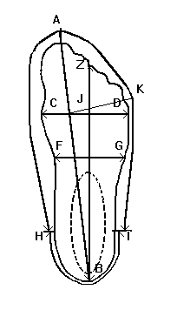
Figure 1: Tracing of the foot. The central line I am talking about is A-B. The point on you inseam I am talking about is roughly where H is, but I would place this point a bit more forward.

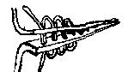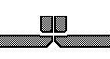
Figure 2: The Flesh/Grain stitch. This stitch is used to join the upper and the sole in older, pre 14th century shoes or simply if you don’t want to deal with a rand.

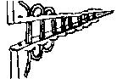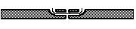
Figure 3: The flesh/edge stitch used to join two pieces of leather "on edge"
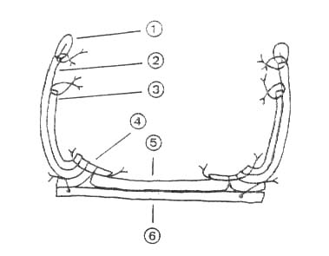
Figure 4: A more complicated shoe, with lining, but showing nicely the arrangement of the various pieces of leather in a shoe with clump sole. The stitching used at 4 is a flesh/grain stitch, going through the upper, lining and rand. It is a flesh/edge stitch going through the sole into and through the rand, lining and upper, all at number 4. Where the clump sole is attached to the rand, the stitching is a flesh/grain stitch through the rand, but a tunnel stitch through the clump sole itself.

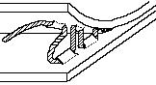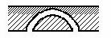
Figure 5: The Tunnel stitch. It is used to attach one piece of leather to another without letting the stitches show on the other side. Examples are the clump sole and the heel stiffener. In that case, however, the stitches would go through the rand then make a tunnel in the sole.

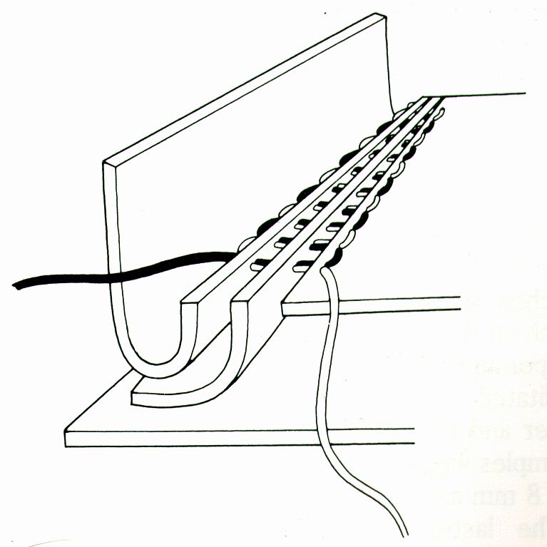
Figure 6: A view to show the stitching of a 15th century shoe with a clump sole. From the sole through the grain, out the edge, into the flesh side of the rand/welt and then into the grain and out the flesh of the upper leather. Also not how the stitch is done with a two needle harness.

